COMPUTER NETWORKS
ASSIGNMENT 3 – CO3
Protocol Performance Analysis: TCP, UDP, HTTP, DNS, QoS, QUIC and TLS 1.3

STUDENT DETAILS
Name | R. Vishwa
Register Number | 1911260146
Programme | B.Tech – Computer Science and Engineering
Course | Computer Networks (CSA07)
Assignment | Assignment 3 – CO3
GitHub Repository | https://github.com/Rvishwa28/CSA07-1911260146-Assignment3

Q1 – Which Socket Gets the Segment?

Socket selection / demultiplexing

Arriving segment | Socket that receives it | Reason
TCP: 49.37.2.8:50001 → 203.0.113.5:443 | Established TCP connection 203.0.113.5:443 ↔ 49.37.2.8:50001 | The complete TCP connection is identified by source IP, source port, destination IP  and destination port.
TCP: 117.96.4.2:50000 → 203.0.113.5:443 | Established TCP connection  203.0.113.5:443 ↔ 117.96.4.2:50000 | The remote IP is different, so this is a  different four-tuple.
TCP SYN: 106.51.7.7:41000 → 203.0.113.5:443 | TCP listening socket on port 443 | A new connection request is delivered to the listening socket; accept() creates a new connected socket after the handshake.
UDP: 49.37.2.8:50000 →  203.0.113.5:5004 | UDP socket bound to 203.0.113.5:5004 | UDP demultiplexing normally selects the socket using the local destination address and port; the application can inspect the  sender address returned by recvfrom().
Two TCP connections can use the same client source port 50000 because their remote IP addresses differ. TCP distinguishes connections using the four-tuple (source IP, source port, destination IP, destination port). A single UDP socket bound to port 5004 can receive datagrams from many viewers, but its local port alone does not identify a viewer. The server must inspect the source address and port of each datagram.

Header overhead calculation
Assumption: IPv4 header = 20 bytes, minimum TCP header = 20 bytes and UDP header = 8 bytes. The payload is 100 bytes.

Protocol | IP + transport headers | Total packet size | Header / payload | Headers as % of total
UDP over IPv4 | 20 + 8 = 28 bytes | 128 bytes | 28/100 × 100 = 28% | 28/128 × 100 = 21.875%
TCP over IPv4 | 20 + 20 = 40 bytes | 140 bytes | 40/100 × 100 = 40% | 40/140 × 100 = 28.57%

UDP has lower header overhead for this small update. TCP may also use options, so its actual header can be larger than the minimum 20 bytes.

Suitable protocol for each application feature
Application feature | Recommended protocol | Reason
Live score updates | TCP | Scores must arrive reliably and in order; a missed score can create an incorrect  display.
Ball-by-ball commentary | TCP | Text is small and reliable ordered delivery  is more important than a very small delay.
Live video | UDP-based real-time transport | A late video packet is often less useful than a newer frame. UDP avoids TCP head-of-line retransmission delays; the application  can tolerate or conceal some loss.

Complete the Code – Python solution
import socket import threading

def udp_server(sock): for _ in range(3):
data, address = sock.recvfrom(1024) sock.sendto(b"ACK:" + data, address)

def tcp_server(sock):
conn, _ = sock.accept() with conn:
total = 0 while True:
data = conn.recv(4096) if data == b"":
break
total += len(data)

print(f"TCP server received {total} bytes in order")

u = socket.socket(socket.AF_INET, socket.SOCK_DGRAM) u.bind(("127.0.0.1", 0))
t = socket.socket(socket.AF_INET, socket.SOCK_STREAM) t.bind(("127.0.0.1", 0))
t.listen(1)
threading.Thread(target=udp_server, args=(u,)).start() th = threading.Thread(target=tcp_server, args=(t,)) th.start()

for name in ("lab1", "lab2", "lab3"):
c = socket.socket(socket.AF_INET, socket.SOCK_DGRAM) c.sendto(name.encode(), u.getsockname())
reply, _ = c.recvfrom(1024)
print("UDP", name, "->", reply.decode()) c.close()

c = socket.create_connection(t.getsockname()) c.sendall(b"x" * 100_000)
c.close()
th.join()
u.close()
t.close()
Expected result: three UDP acknowledgements (ACK:lab1, ACK:lab2, ACK:lab3) and `TCP server received 100000 bytes in order`. The exact spacing depends on the print statement.

Conclusion
UDP is not suitable for every application, but it is not useless. It provides low overhead and avoids transport-level retransmission delays, which is useful for real-time video and voice. TCP is preferable when reliable, ordered delivery is required, such as score records and commentary. The protocol must be selected according to the application's delay and reliability requirements.

Q1 – SAMPLE PROGRAM OUTPUT
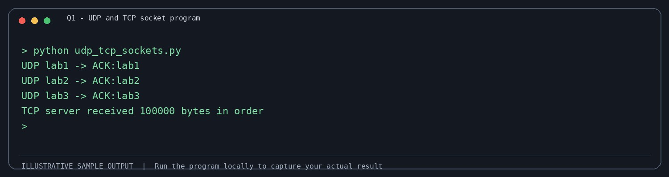

Q2 – Read the Congestion Window

Congestion-window and threshold analysis
The question-paper text extraction does not preserve the spacing of the RTT/cwnd row perfectly. The intended trace appears to show slow start (1, 2, 4, 8, 16), congestion avoidance, and a reduction at RTT 8. For the calculations below, the supplied code's loss set {8, 14} is used.

Point | Calculation / interpretation
Initial ssthresh | 16 segments (given in the code).
After loss at RTT 8 | If cwnd immediately before the loss is 19, ssthresh = max(19 // 2,  2) = 9 segments.
After loss at RTT 14 | If cwnd immediately before the loss is 14, ssthresh = max(14 // 2,  2) = 7 segments.
Loss type | The trace alone shows a congestion-window reduction, but cannot prove whether the event was three duplicate ACKs or a timeout unless the graph/packet trace shows the event details.
TCP variant | A reduction to about half the window indicates Reno fast recovery; a drop to 1 segment indicates Tahoe or a timeout response.

At RTT 7, using cwnd = 18 segments from the apparent trace, segment size = 1,460 bytes and RTT = 0.04 s: Throughput ≈ (18 × 1,460 × 8) / 0.04 = 5,256,000 bits/s = 5.256 Mbps.
AIMD gives approximate fairness because each sender increases its rate additively when the link is underused and reduces its rate multiplicatively when congestion occurs. A sender with a larger share loses more in absolute terms, moving competing senders toward a fairer share.
•

Complete the Code – Python solution
def simulate(losses, ssthresh=16, reno=True): cwnd, trace = 1, []
for rtt in range(1, 21): trace.append(cwnd) if rtt in losses:
ssthresh = max(cwnd // 2, 2) cwnd = ssthresh if reno else 1
elif cwnd < ssthresh:
cwnd = min(cwnd * 2, ssthresh) else:
cwnd += 1 return trace

for label, reno in (("Reno", True), ("Tahoe", False)): tr = simulate({8, 14}, reno=reno)
print(label, " ".join(f"{w:2d}" for w in tr), f"| segments sent {sum(tr)}")
This code follows the algorithm described in the assignment. Its output should be generated locally and compared with the expected-output line in the question paper; the extracted expected-output formatting is unclear.

Conclusion – CUBIC or BBR
For high-speed hostel links with long RTT, CUBIC is a practical general-purpose choice because it is widely deployed and probes for available capacity. BBR can provide better throughput when random non-congestion loss causes Reno/CUBIC-style loss reactions, because BBR estimates bottleneck bandwidth and RTT rather than treating every loss as congestion.

Q2 – SAMPLE PROGRAM OUTPUT
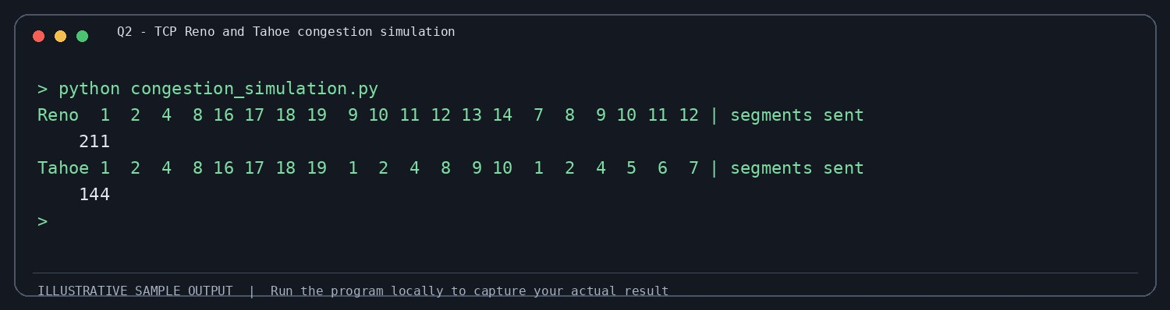

Q3 – Why Does the Home Page Take 8 Seconds?

Page-load calculations
Given: 1 HTML file + 80 small objects, RTT = 50 ms = 0.05 s, and transmission time is negligible. The calculations use the standard simplified HTTP timing model and include one RTT for TCP connection establishment where applicable.

HTTP method | Calculation | Estimated time
Non-persistent, one connection at a time | 81 objects × 2 RTT × 50 ms | 8.10 s
Persistent HTTP/1.1, no pipelining | 1 RTT TCP setup + 81 RTT  request/response | 4.10 s
Persistent HTTP/1.1 with pipelining | 1 RTT setup + 1 RTT for HTML + 1 RTT  for pipelined objects | 0.15 s
Six parallel non-persistent connections | HTML: 2 RTT; 80 objects in ceil(80/6)=14  waves × 2 RTT; total 30 RTT | 1.50 s

The exact timing can differ due to DNS lookup, TLS handshake, server processing, congestion, browser scheduling and object dependencies. These are excluded from the simplified calculation.

HTTP/2 and HTTP/3
HTTP/2 multiplexes multiple streams over one TCP connection. If a TCP segment is lost, TCP withholds later bytes until the missing bytes are retransmitted. This can delay delivery to multiple HTTP/2 streams, known as TCP head-of-line blocking. HTTP/3 uses QUIC over UDP. QUIC has independent streams, so loss affecting one stream does not necessarily block delivery on other streams.

Cache headers
  - Cache-Control: max-age tells the browser how long an object can be reused while fresh. A fresh cached object can be used without a network request, saving approximately the request/response RTTs and body transfer time for that object.
  - ETag gives an object a validator. On a later visit, the browser can send If-None-Match. If unchanged, the server returns 304 Not Modified, saving the response body but still requiring a network round trip.
The question does not provide object sizes or cache lifetime, so an exact number of seconds saved on the second visit cannot be calculated.

Q3 – SAMPLE PROGRAM OUTPUT
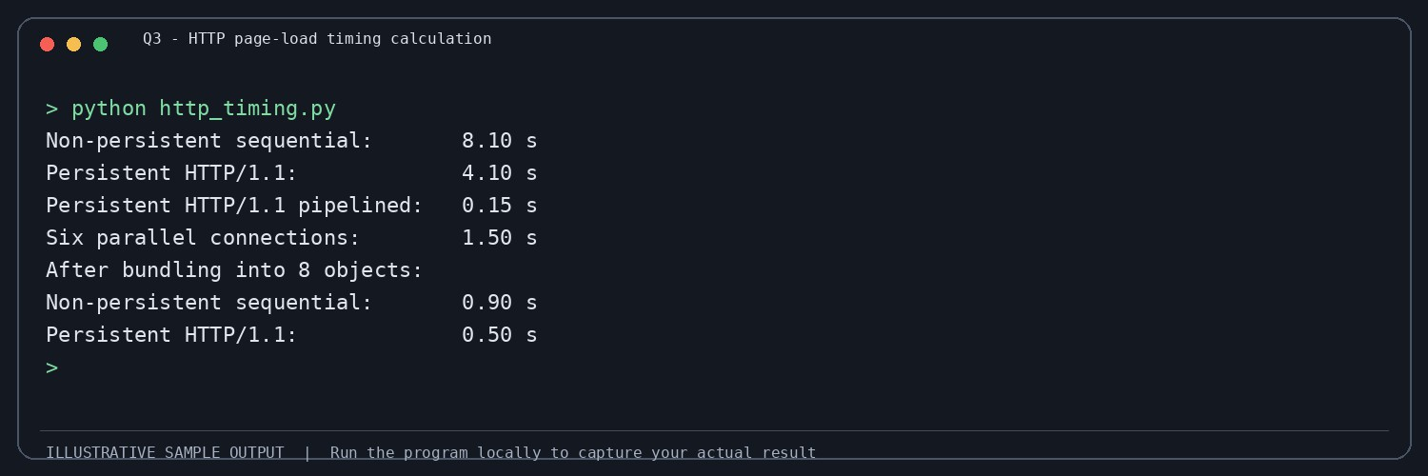

Q4 – How Many Queries Reach the University’s DNS Server?

Queries per hour
A resolver generally needs to refresh a cached record when its TTL expires. Assuming continuous demand and one refresh per TTL interval:

TTL | Refreshes per hour per resolver | If there is one resolver in each of 40  cities
300 seconds | 3600 / 300 = 12 | 40 × 12 = 480 queries/hour
30 seconds | 3600 / 30 = 120 | 40 × 120 = 4,800 queries/hour

The number of individual students has little direct effect while their requests are served from the same resolver cache. The number of distinct resolvers and the TTL determine how often the authoritative server is queried. The 40-city total assumes one resolver per city; real ISPs may operate many resolvers.

Recursive and iterative DNS
A phone usually sends a recursive query to its configured resolver and expects a final answer. The resolver performs iterative lookups: it contacts a root server, follows the referral to the .in TLD server, follows the referral to the ac.in delegation, and then contacts the authoritative server for simats.ac.in. The exact delegation path depends on the DNS hierarchy and cached referrals.

DNS record types and transport

Record | Purpose
A | Maps a host name to an IPv4 address.
AAAA | Maps a host name to an IPv6 address.
CNAME | Aliases one name to another canonical name.
MX | Identifies mail exchangers for the domain.
NS | Identifies authoritative name servers for a zone.
TXT | Stores text data used for verification and email security policies.
DNS commonly uses UDP because queries and answers are usually small and UDP has low overhead. DNS can use TCP for large responses, zone transfers and cases where truncation or protocol requirements call for TCP.

Long TTL risk
A long TTL reduces repeated queries and authoritative-server load. However, if the result server IP address changes during result day, resolvers may continue using the old cached address until the TTL expires. This can send students to an unavailable or outdated server.

Complete the Code – Python solution
SERVERS = {
"root": {"in.": "tld-in", "com.": "tld-com"},
"tld-in": {"ac.in.": "ns-ac"},
"tld-com": {"example.com.": "ns-example"},
"ns-ac": {"simats.ac.in.": "ns-simats"},
"ns-simats": {"results.simats.ac.in.": "10.20.30.40"},
"ns-example": {"www.example.com.": "93.184.216.34"},
}
cache = {}

def resolve(name): if name in cache:
return cache[name], 0 server, queries = "root", 0 while True:
queries += 1
matches = [(suffix, target)
for suffix, target in SERVERS[server].items() if name.endswith(suffix)]
if not matches:
raise LookupError(f"No DNS referral for {name} at {server}") suffix, target = max(matches, key=lambda item: len(item[0]))
if any(ch.isdigit() for ch in target): cache[name] = target

return target, queries server = target

for n in ("results.simats.ac.in.", "www.example.com.", "results.simats.ac.in."):
ip, q = resolve(n)
print(f"{n:<24} {ip:<15} queries sent: {q}")
The third lookup sends zero queries because the first lookup stored the answer in the local cache. A real cache must also store an expiry time and remove an entry after its TTL. This short exercise uses a simple dictionary cache and does not implement TTL expiry.

Q4 – SAMPLE PROGRAM OUTPUT
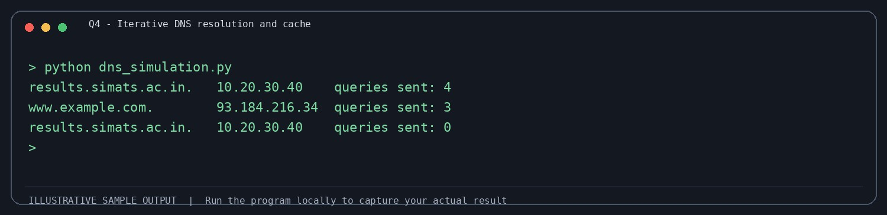

Q5 – When Will the Video Call Freeze?

M/M/1 calculations
Given service rate μ = 1,000 packets/second. For arrival rate λ, utilisation ρ = λ/μ, average number in system L = ρ/(1−ρ), and average time in system W = 1/(μ−λ).

Arrival λ (pkt/s) | Utilisation ρ | Average packets L | Average delay W
500 | 0.50 | 1 | 2 ms
800 | 0.80 | 4 | 5 ms
900 | 0.90 | 9 | 10 ms
950 | 0.95 | 19 | 20 ms
990 | 0.99 | 99 | 100 ms
1000 | 1.00 | Unstable | Queue grows without limit

The average delay first exceeds 20 ms at 990 packets/second in the supplied test values. At 950 packets/second it is exactly 20 ms.
The question states that doubling load from 450 to 900 packets/second multiplies delay by ten. Using the stated M/M/1 formula, W(450)=1/(1000−450)=1.818 ms and W(900)=1/(1000−900)=10 ms, which is a factor of 5.5, not ten. A tenfold increase occurs from 500 to 950 packets/second (2 ms to 20 ms).

Token bucket burst
Bucket size = 1 MB = 8 megabits. Backup offered rate = 10 Mbps and token rate = 2 Mbps. Excess rate that drains the bucket
= 10−2 = 8 Mbps. Burst duration = 8 megabits / 8 Mbps = 1 second. After this, the backup is limited to the configured average rate of 2 Mbps.

DiffServ classes

Traffic | Suggested class | Reason
Interactive voice/video | EF (Expedited Forwarding) | Low delay, low jitter and low loss are  important; admission control is needed.
Important backup/file transfer | AF (Assured Forwarding) | Can receive a configured bandwidth share  while tolerating more delay.
Ordinary web browsing and non-critical  traffic | Best effort | No strict latency guarantee is required.

Complete the Code – Python solution
def mm1(lam, mu): if lam >= mu:
return None rho = lam / mu
L = rho / (1 - rho) W = 1 / (mu - lam) return rho, L, W

mu = 1000
for lam in (500, 800, 900, 950, 990, 1000):
r = mm1(lam, mu) if r is None:
print(f"load {lam:4d} pkt/s: unstable, queue grows without limit") else:
rho, L, W = r
print(f"load {lam:4d} pkt/s: rho {rho:.2f} L {L:6.1f} pkts " f"W {W * 1000:6.1f} ms")

Capacity and engineering decision
For λ = 1,500 packets/second and W < 10 ms: 1/(μ−1500) < 0.01, so μ−1500 > 100 and μ > 1,600 packets/second. Therefore, the service capacity must be greater than 1,600 packets/second to keep the modelled average delay strictly below 10 ms.
If the link is doubled to μ = 2,000 packets/second and total load is 1,800 packets/second, W = 1/(2000−1800) = 0.005 s = 5 ms. Strict priority on the old link may protect video from backup traffic, but exact video delay cannot be calculated without the video arrival rate, packet sizes and scheduling details. A faster link increases total capacity; QoS controls how capacity is shared. A combination of adequate capacity and QoS is preferable.

Q5 – SAMPLE PROGRAM OUTPUT
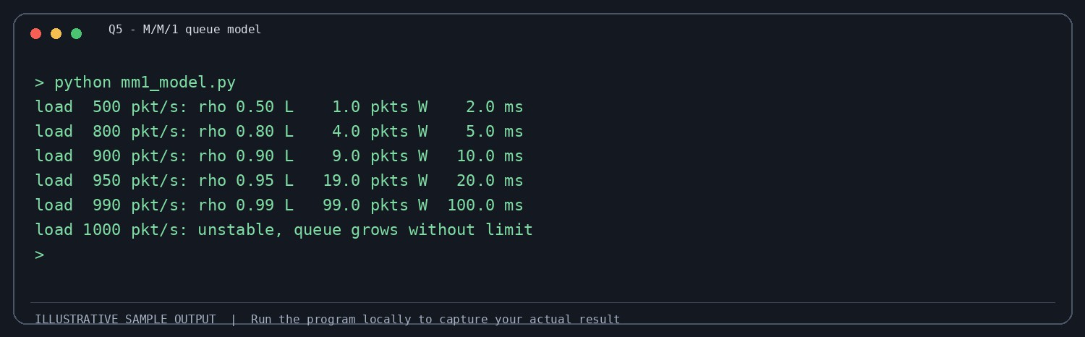

Q6 – Count the Round Trips Before the First Byte

Connection setup time
Given RTT = 100 ms. The estimates below count protocol round trips before application request data can be sent, assuming a full handshake and no DNS delay.

Method | Round trips | Estimated time
TCP + TLS 1.2 | 1 RTT TCP + 2 RTT TLS = 3 RTT | 300 ms
TCP + TLS 1.3 | 1 RTT TCP + 1 RTT TLS = 2 RTT | 200 ms
QUIC, first visit | 1 RTT for combined QUIC/TLS 1.3  handshake | 100 ms
QUIC 0-RTT resumption | Application data can be sent with the first  flight | Approximately 0 ms wait before sending  early data

0-RTT does not mean the server has already received or processed the request instantly; it means the client can send early data without waiting for a new handshake round trip.

0-RTT replay risk
An attacker who captures early data may be able to replay it. Therefore, 0-RTT should be limited to safe, idempotent requests, such as fetching a public page. Requests that create financial or irreversible effects, such as transferring money, making a payment or submitting an order, must not be sent as replayable 0-RTT data.

QUIC connection migration
QUIC uses a connection ID that is not tied only to the phone's current IP address and port. When the phone moves from Wi-Fi to 5G, QUIC can validate the new network path and continue the same connection. A traditional TCP connection is identified by its IP/port tuple; a change of address normally breaks that connection and requires a new TCP/TLS connection.

Firewall handling and experiment
Some enterprise firewalls block UDP traffic, including QUIC, because their policies inspect or allow TCP more commonly. The application should detect that QUIC cannot be established and fall back to HTTPS over TCP with TLS 1.3 (normally HTTP/2 or HTTP/1.1).
  - Capture a TLS 1.3 handshake in Wireshark and label ClientHello, ServerHello, EncryptedExtensions, Certificate (when sent), CertificateVerify and Finished as visible in the capture.
  - Use `openssl s_client -connect example.com:443 -tls1_3` and repeat with another website; record whether the handshake succeeds.
  - Check the browser Network panel for the negotiated protocol (h2 or h3). Add delay in a network emulator and compare setup time.

Conclusion
The bank's app should support QUIC because it can reduce connection setup delay and can migrate across network changes. It must disable 0-RTT for non-idempotent banking operations and provide a secure TCP/TLS fallback for networks that block UDP.

Q6 – SAMPLE PROGRAM OUTPUT
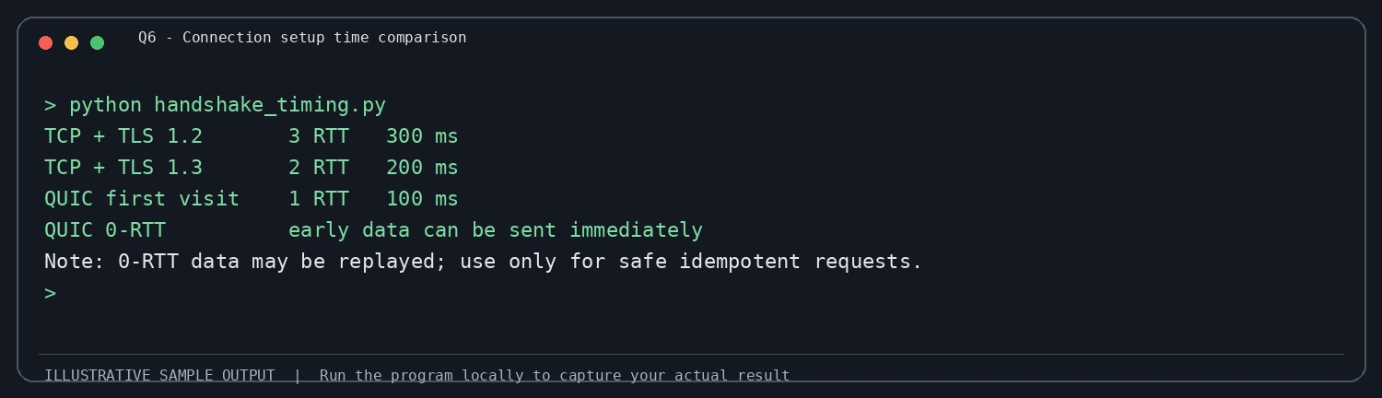

Q7 – Choose the Protocols from First Principles

Stage 1 – Interpret the problem

Traffic type | Main requirements
Live video consultation | Very low delay and jitter; tolerate some packet loss; secure media;  newest frames are more useful than delayed retransmissions.
Patient records and X-ray images | Reliable, ordered, complete delivery; integrity and confidentiality;  transfer can tolerate more delay than live video.
Chat | Reliable, ordered delivery; low delay; confidentiality and  authentication.
Hospital service-name lookup | Fast name resolution; cached answers; correct and available DNS  data.
Measurable design targets (proposed): video one-way application delay below 150 ms where the network permits, jitter below 30 ms, and packet loss preferably below 1–2%; records and images must arrive with 100% integrity verified by file size/hash; chat messages must be delivered in order with acknowledgement; DNS cached lookups should normally complete within tens of milliseconds. On 100–300 ms RTT 4G links, the video delay target may not always be achievable, so the application must adapt bitrate and resolution.

Stage 2 – Compare candidate protocols
Protocol | Best use in this platform | Evaluation
TCP | Patient records, X-ray files and reliable  chat | Reliable and ordered; retransmission helps  completeness but can add delay under loss.
UDP | Real-time media transport | Low overhead and no built-in retransmission; application handles loss, jitter and congestion.
QUIC | Secure interactive application transport and HTTP/3 | Runs over UDP, integrates TLS 1.3, supports independent streams and connection migration.
HTTP/2 | Web API, records and chat over TCP | Multiplexes streams, but TCP loss can  block all streams temporarily.
HTTP/3 | Web API and file transfer over QUIC | Multiplexes independent QUIC streams and avoids TCP-level head-of-line blocking between streams.
TLS 1.3 | Confidentiality and authentication for TCP  applications | Modern secure transport security with  fewer handshake round trips than TLS 1.2.
TCP throughput limit from the given window: Throughput ≤ Window / RTT = 64 KB × 8 / 0.3 s. Using 64 KiB = 65,536 bytes: (65,536 × 8) / 0.3 = 1,747,627 bits/s ≈ 1.75 Mbps. This is the window-limited throughput before considering other bottlenecks. Large X-ray files may take longer to transfer, especially on 300 ms RTT links; larger TCP windows, window scaling and a suitable congestion-control algorithm can improve throughput.
DNS configuration: use redundant recursive resolvers, authoritative DNS with A and AAAA records, suitable TTLs and monitoring. Enable DNSSEC validation where supported. QoS: prioritise interactive voice/video with a controlled low-latency class, give clinical chat and API traffic assured service, and place bulk X-ray transfers/backup in a lower-priority class without starving them.

Stage 3 – Implement and verify
The following small TCP examples demonstrate reliable file transfer and chat. Execute them on two terminals or two computers on the same test network. For a full evaluation, add delay and loss with tc/netem or a simulator, then record transfer time, file hash and chat delivery.

TCP file receiver
# receiver.py import socket
with socket.socket() as server: server.bind(("0.0.0.0", 5001)) server.listen(1)
conn, addr = server.accept()
with conn, open("received_xray.bin", "wb") as f: while True:
data = conn.recv(4096) if not data:

break f.write(data)
print("File received successfully")

TCP file sender
# sender.py
import socket, time start = time.time()
with socket.create_connection(("127.0.0.1", 5001)) as s: with open("sample_xray.bin", "rb") as f:
while True:
data = f.read(4096) if not data:
break s.sendall(data)
print("Transfer seconds:", round(time.time() - start, 3))

Simple TCP chat
# chat_server.py import socket
with socket.socket() as server: server.setsockopt(socket.SOL_SOCKET, socket.SO_REUSEADDR, 1)
server.bind(("0.0.0.0", 5002)) server.listen(1)
conn, addr = server.accept() with conn:
while True:
data = conn.recv(1024) if not data:
break
print("Client:", data.decode(errors="replace")) conn.sendall(b"Message received")
Verification checklist: record baseline transfer time; apply 100 ms, 200 ms and 300 ms RTT; test 1% and 5% packet loss; record transfer time, file size and SHA-256 hash; send multiple chat messages and confirm order and acknowledgement. Do not claim measured results until the tests are run.

Stage 4 – Defend the design
Use UDP-based real-time media with adaptive bitrate and jitter buffering for video. Use QUIC/HTTP/3 or TCP with TLS 1.3 for APIs, chat and data transfer; use reliable streams for patient records and X-ray images. Use secure DNS and QoS to protect interactive traffic. Measurements should demonstrate video delay, jitter, packet loss, file integrity and transfer time.
If the links are upgraded to 5G, lower RTT and higher bandwidth can improve video quality and reduce X-ray transfer time. The application should still use adaptive media, encryption, congestion control and fallback paths because 5G coverage and loss can vary.

Q7 – SAMPLE PROGRAM OUTPUT


